A Manual for the WEB-grading System

April 3, 2014
Aoyama gakumu-bu kyomuka
Sagamihara jimu-bu gakumu-ka

- How to access the WEB-grading system 成績入力

- Login to the AOYAMA-portal（https://aoyama-portal.aoyama.ac.jp/）
To access the WEB-grading system, start by a login to the AOYAMA-portal.
To create a password or to change your existing password, visit the PC Support Lounge.

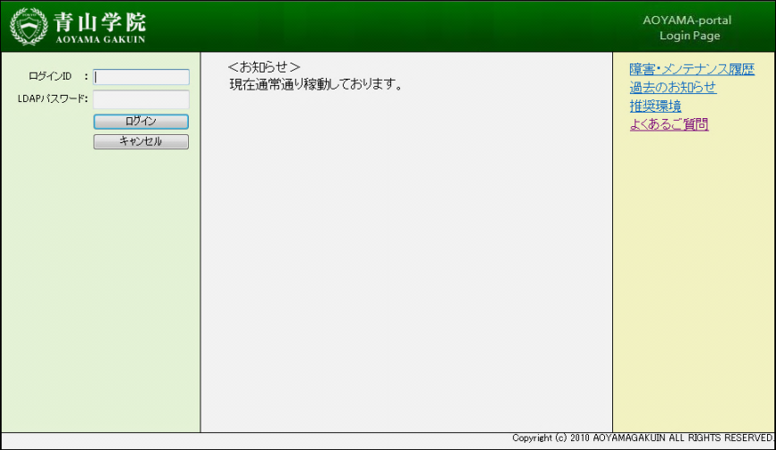

※If you cannot login to the AOYAMA-portal, please refer to page 12 to learn how to contact the PC Support Lounge.

- Click 教員事務ＷＥＢ (“Instructor administration WEB”)
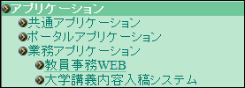

- Click 成績入力 (“Enter grades”)
After a MENU page appears, click on the link marked成績入力 (“Enter grades”).
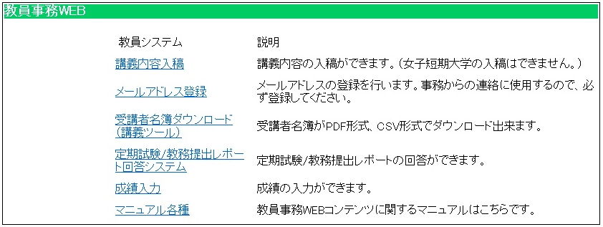

- How to use the WEB-grading system 成績入力

1. TOP page of the WEB-grading system
A list of courses for which you need to submit grades will appear on your TOP page.
Select the course by clicking the 選択 (“select”) button. A Student ID column will appear where you can enter student grades.
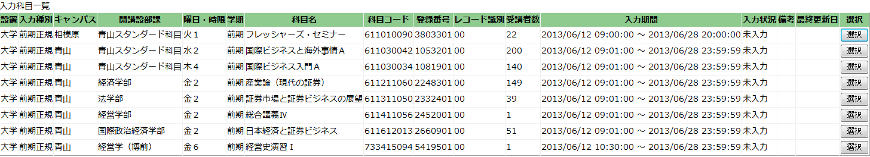
※If any of your courses do not appear on the list, please contact the academic affairs office.

2. Basic operation of WEB-grading system
※ 4 patterns are listed below. Please follow these instructions.
To download class rosters and then grade and upload CSV data.
To upload grades with your own students’ list data.
To input grades directly on the Web.
To upload grades with class roster CSV data.

Refer to instructions (D)
Refer to instructions (C)
Refer to instructions (B)
Refer to instructions (A)

＜Sample image of Student ID column page＞
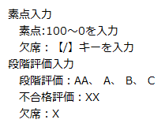
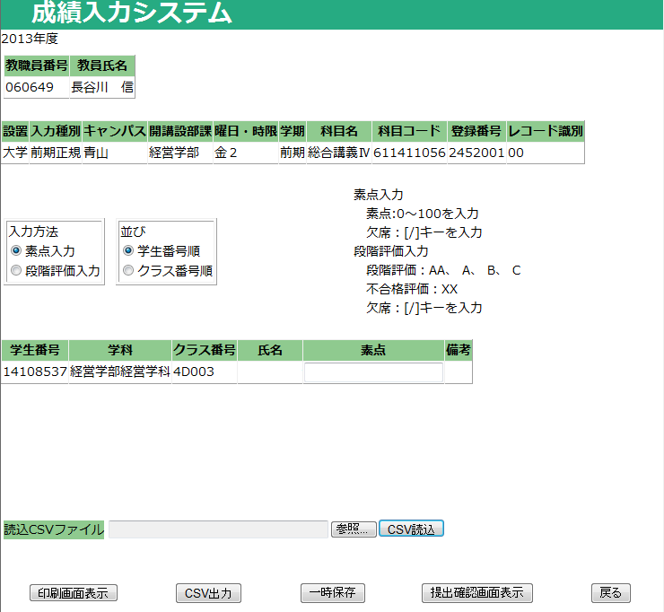

（A）Inputting grades directly on the WEB
- Choose the method to input grades.
Grades may be entered either by 素点入力 (“numeric score”) [i.e. a number from 0 to 100] or by 段階評価入力 (“letter grade”) [i.e. AA, A, B, C, X, or XX]（The default setting for inputting grades is by numeric score).

※ Once you begin inputting grades, YOU CANNOT CHANGE from a numeric to letter grade method or vice versa. If you do, any grades you have already input will be erased.
※ Some courses will only allow you to input grades with a numeric score.
※ Grades for graduate schools courses (except for those in the “Graduate School of Science and Engineering” or the “Graduate School of Social Informatics”) must be entered as a numeric score.

- Choose the order for displaying student names.
Student names may be displayed on the screen numerically by「学生番号順」(“student ID”) or by「クラス番号順」(“class number”).（The default is display the students by their ID).

- Input grades directly into the column.
Once you have completed steps ① and ②，you can begin inputting grades one at a time directly into the grade column. Both number and letter grades should be entered. For inputting letter grades, you can use either large or small-cap letters. When you press the Enter key, the cursor automatically moves to the next student in the column. Please BE CAREFUL to input each student grade in the correct place.

Jump to page 9, No 3 – 5 to learn how to save data, print grade sheets and submit the grades.

＜Sample image of Student ID column page＞
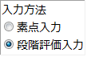
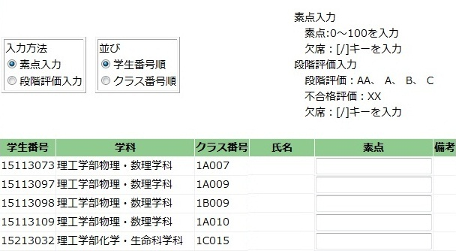
①
②
③

（B）Uploading grades with class roster CSV data
※You can download class roster data from教員事務ＷＥＢ (“Instructor administration WEB”). Click 受講者名簿ダウンロード (“Download class roster”) on the TOP page to download the data. If you have already downloaded the class roster data (CSV formatted), please follow the instructions below. (Note: The instructions are based on a Microsoft Excel operation.)

- Open the student roster CSV data and input grades into any blank column.
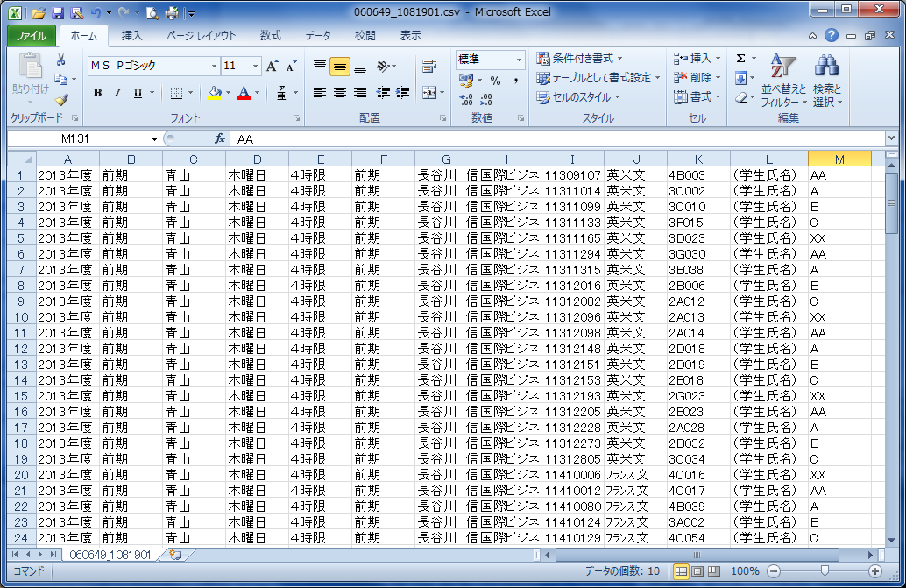
Input grades in any blank column.

- Select「File」→「Save as」 and name the file into which you have input grades. Save it in a CSV file format.（You can save it to any location on your PC.）

※ When you save the CSV data file, an alert message might appear. Click YES to all alerts.

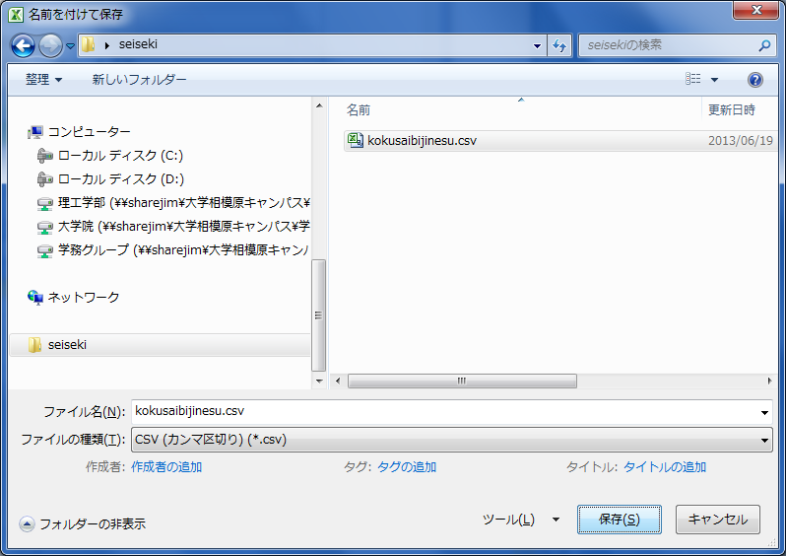

- The Kyomuka only needs two columns of data, one for “student ID numbers” and the other for “grades.” Process the data file as follows. First, erase all other unnecessary columns of data. Next, arrange the “Student ID numbers” into column A and “Grades” into column B.
「Save」the file and close Excel.
※After you save the CSV data file, alert messages may appear. Click YES to all alerts.
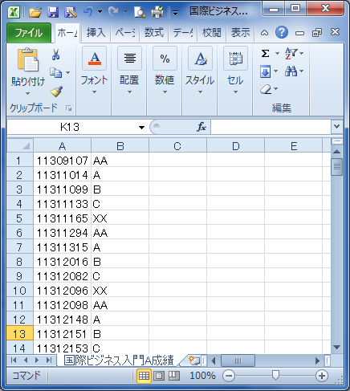
Arrange “Student ID numbers” in column A and “Grades” in column B.

- Open the Student ID column of the WEB-grading system and choose the method of grading, either by 素点入力 (“numeric score”) [i.e. a number from 0 to 100] or by 段階評価入力 (“letter grade”) [i.e. AA, A, B, C, X, or XX]（The default setting for inputting grades is by numeric score). Click the 参照 (“browse”) button which you can find on the bottom of the page. Then select the CSV file you processed in ①～③ and click the CSV読込 (“load file”) button.
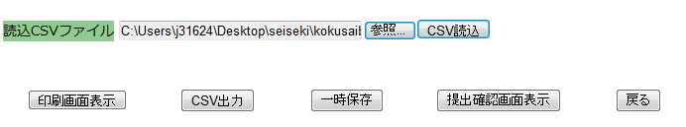

- If you have uploaded the data properly, grades will appear in the Student ID column as in the picture below.
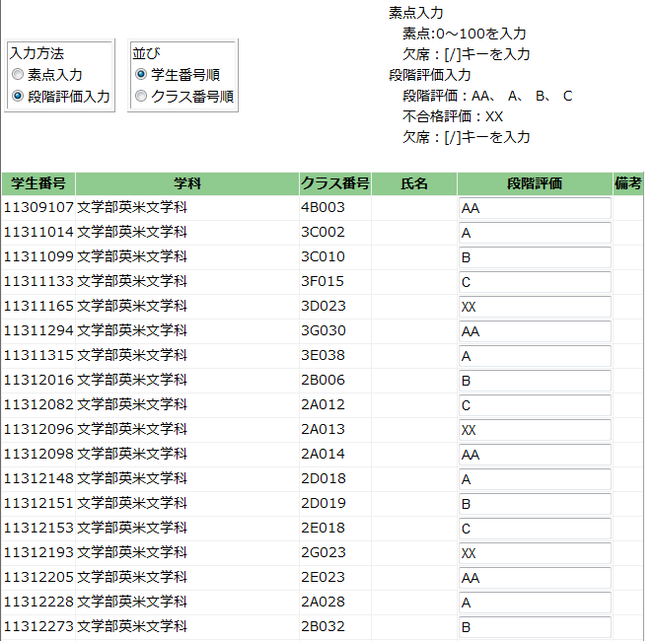

Jump to page 9, No 3 – 5 to see how to save data, print out grade sheets and submit grades.

（C）Uploading grades with your own arranged students’ list
※ If you already have downloaded the class roster data (CSV formatted) from教員事務ＷＥＢ (“Instructor administration WEB”) and arranged it your own way, please follow the instructions below. (Note: The instruction is based on a Microsoft Excel operation.)

- Open your students’ data list and input the grades in any blank column and save the file.
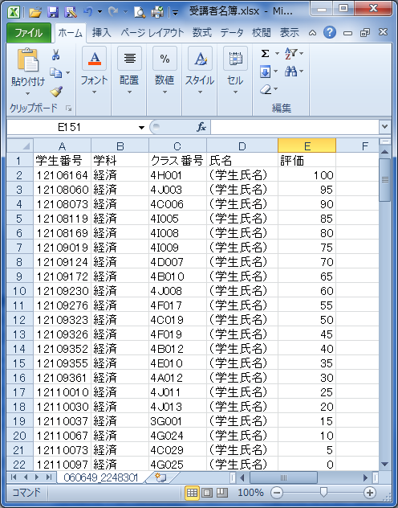
Input grades in any blank column.

- We only need two columns of data, one for “student ID numbers” and the other for “grades.” Process the data file as follows. First, erase all other unnecessary columns of data. Next, arrange the “Student ID numbers” in column A and “Grades” in column B.
No other data is needed.

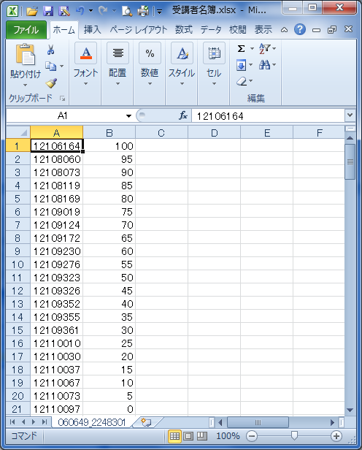
＜Attention points＞
・Should be arranged as: Student ID numbers in column A and grades in column B.
・No other data is needed.
（Erase all other unnecessary data other than Student ID numbers and grades.）

- Select「File」→「Save as」 and name the file you have inputted grades, save as CSV file format.（You can save the file to any location on your PC.）
- ※ When you save the CSV data file, an alert message might appear. Click YES to all alerts.
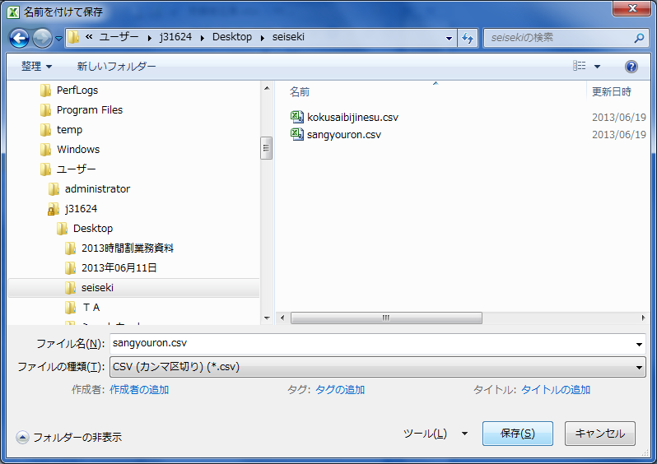
・Use alphabet and numbers.
・Save as CSV file format.

- Open the Student ID column of the WEB-grading system and choose the method of grading, either by 素点入力 (“numeric score”) [i.e. a number from 0 to 100] or by 段階評価入力 (“letter grade”) [i.e. AA, A, B, C, X, or XX]（The default setting for inputting grades is by numeric score). Click the 参照 (“browse”) button which you can find on the bottom of the page. Then select the CSV file you processed in ①～③ and click the CSV読込 (“load file”) button.

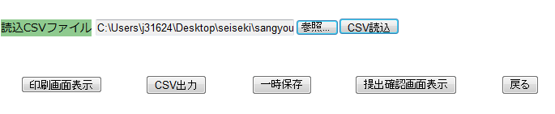

- Grades will appear in the Student ID columns as in the picture below when the data is uploaded properly.
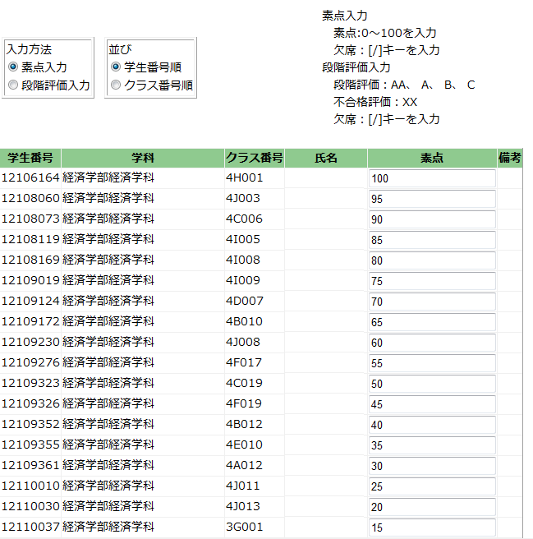
Jump to page 9, No 3 – 5 to see how to save the data, print grade sheets and submit grades.
（D）Downloading the students list in a CSV file from the WEB-grading system and grading, then uploading the data

- First, open the Student ID column of the WEB-grading system and choose the method of grading, either by 素点入力 (“numeric score”) [i.e. a number from 0 to 100] or by 段階評価入力 (“letter grade”) [i.e. AA, A, B, C, X, or XX]（The default setting for inputting grades is by numeric score). Next, click the CSV出力 (“CSV output”) button which you can find on the bottom of the page.

- A “File download” window will appear. Click 保存 (“save”) to save the file.（You can save the file to any location on your PC.）
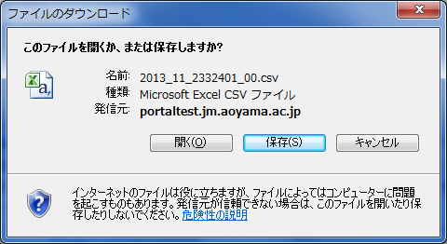

- Open the file which you have saved in ②.
（Note: The instruction is based on Microsoft Excel operation.）
1) Student ID numbers will appear in column A. Input grades in column B and save the data.
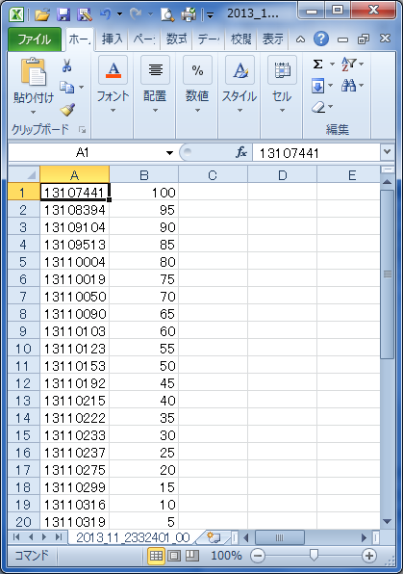
Student ID numbers will appear in column A.
Input grades in column B using half-width characters.

2) Go back to the WEB-grading system and click the 参照 (“browse”) button which you can find on the bottom of the page. Then select the CSV file you input grades in and click the CSV読込 (“load file”) button.
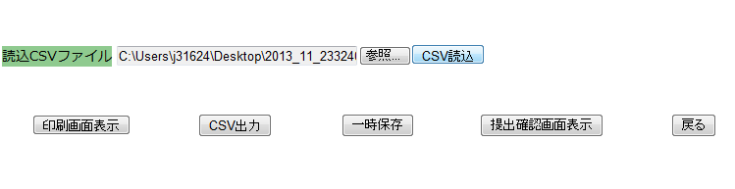
3) Grades will appear in the Student ID column as in the picture below when the data is uploaded properly.
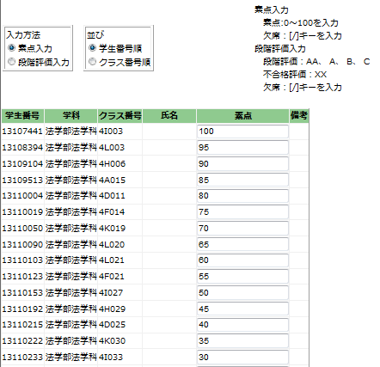
Follow the instruction below No 3 – 5 to see how to save the data, print out grade sheets and submit grades.

3. How to save grades temporarily
If you like to save grading data temporarily, click the 一時保存 (“save draft”) button that
appears on the bottom of the page.
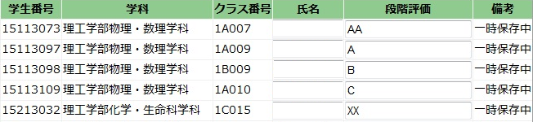
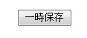

If you want to change the grades again, input new grades in the column and click一時保存 . Data will be overwritten.

4. Trouble Shooting
The following notes cover some possible errors that might occur. If an error message appears, it means the “grading data is not complete”. Please note that you cannot submit grades without completing all the necessary data.

1) If there are any blank cells;
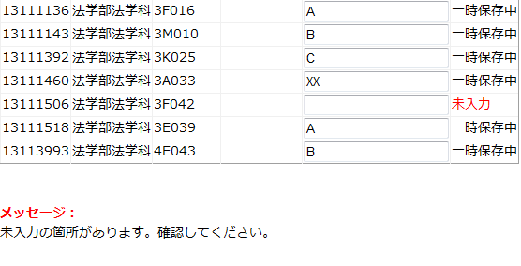

2) If the grades are not input correctly;
Example: Choosing the numeric scores method of grading but inputting a letter grade
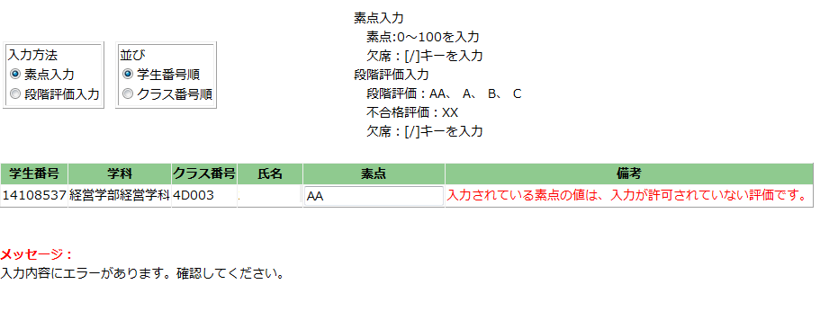
Example: Choosing the letter method of grading but inputting a letter which is not used for grading
（”S”,”D”,”F” etc.）

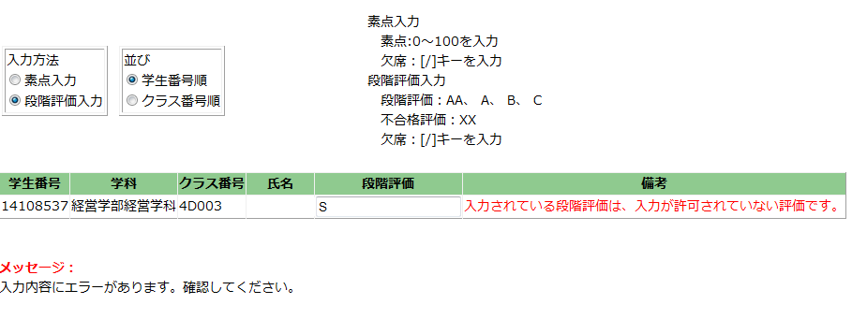

5. Printout Function

Click the 印刷画面表示 (“show print screen”) button which you can find on the bottom of the page. Print preview screen will appear. Click the “Print” option from your Internet browser to print a grade sheet out.

[Warning!] Please save your data before printing out. In other words, click the 一時保存 (“save draft”) or 提出 (“submit”) button FIRST! If you click印刷画面表示 (“show print screen”) before you save your data, all the grades will be erased.
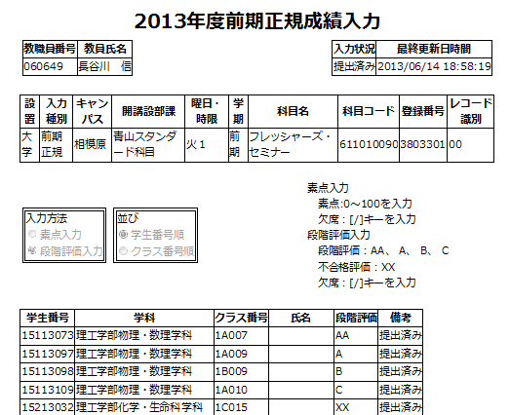

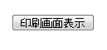

You can print out a grading sheet as above.
To print these sheets, use the “Print” function of your Internet browser.

6. Submitting Grades

- When you finish grading all the courses, click the 提出確認画面表示 (“show submission confirmation screen”) button on the bottom of the page. A confirmation screen will appear where you can check that the grading data is completed correctly. Please ensure that you check the data before submitting it. Click the 提出 (“submission”) button on the bottom of the confirmation screen to submit the data.
[Warning!]
Once you have submit the data, you CAN NOT CHANGE/CORRECT any grading data.
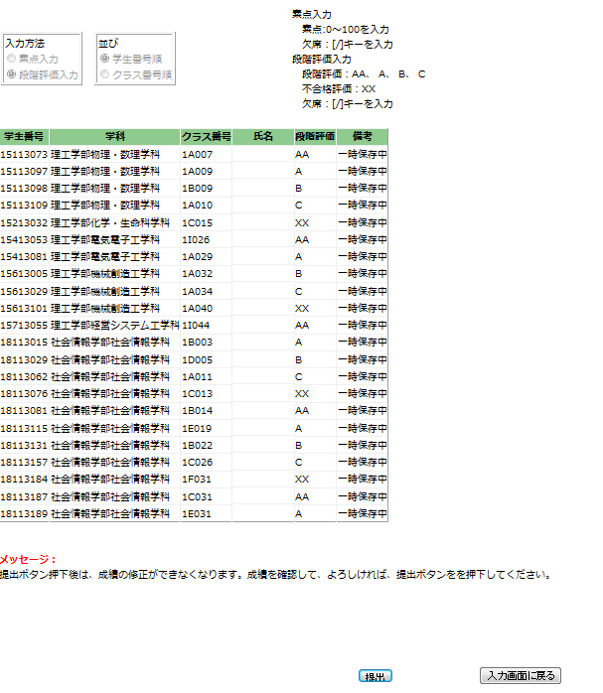
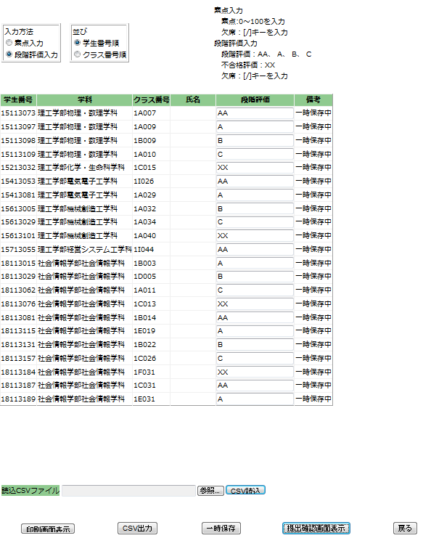

- After you submit the data, the message listed below will appear on the bottom of the page.
You will also receive an e-mail letting you know that the data has been submitted to your Aoyama Gakuin email address. (tXXXXX(X:5 lower digits of your ID No )@aoyamagakuin.jp)
You can also check whether or not you have submitted the data properly on the TOP page of the system. If the letter appeared in the status section as「提出済み」(“submitted”), it means you have submitted the grades.

＜Courses of Aoyama Campus＞
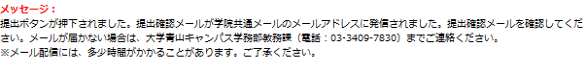
＜Courses of Sagamihara Campus＞
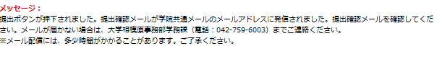

- If you have any inquiries regarding the grades you have submitted, please review the section listed in “6. References / Contacts” as soon as possible.

7. References / Contacts

＜Inquiries regarding grades and WEB-grading system＞ (Schools and Graduate Schools)
Aoyama kyomu-ka (undergraduate and graduate school office)
Sagamihara gakumu-ka (undergraduate and graduate school office)

＜If you cannot login to the AOYAMA portal＞
- Please refer to the よくある質問 (“FAQ”) section of the login page of the AOYAMA portal.
- If you still have inquiries regarding how to login to the AOYAMA portal, please contact the PC Support Lounge.

PC Support Lounge Aoyama Campus (1st Floor, Bldg. 2) TEL:03-3409-7850

PC Support Lounge Sagamihara Campus(4th Floor, Bldg. B) TEL:042-759-6047

※Please bring your Aoyama Gakuin identity-card with you when you visit the PC Support Lounge.

